Experiment 7
Name – Parth Wankhede PRN - 25070521159

Algorithm
Step 1: Start
Step 2: Declare three variables a, b, and c
Step 3: Read values of a, b, and c using input().split()
Step 4: Print a + b + c
Step 5: Print a + c + b
Step 6: Print b + a + c
Step 7: Print b + c + a
Step 8: Print c + a + b
Step 9: Print c + b + a
Step 10: Stop

Flowchart:
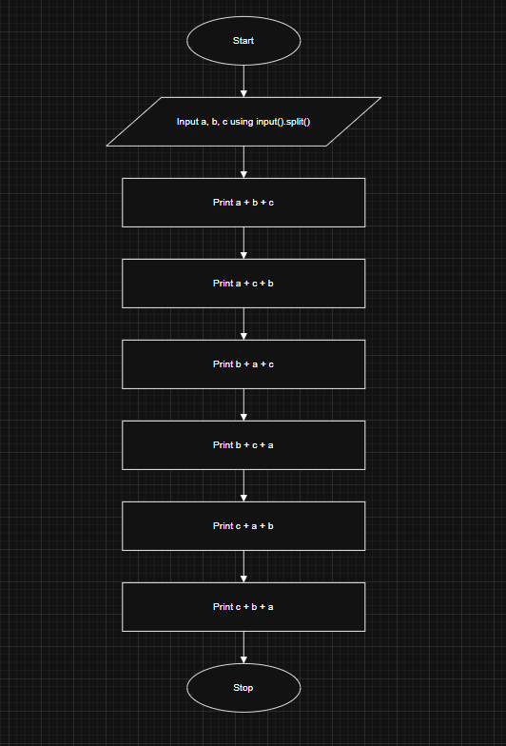

Execution:
